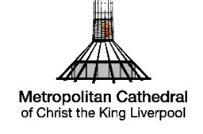

ACCESSIBILITY POLICY

• We seek, wherever possible, to offer all visitors and users of the Cathedral equality of access.

• We want to make the Metropolitan Cathedral more
welcoming and helpful, breaking down barriers which may have in the past excluded some people.

• We welcome the opinions and advice of people with
problems of access and, where appropriate, their carers.

• We will try to offer appropriate support to anyone who has
problems of access and their families.

TO THIS END

• We have undertaken an access audit to identify barriers which prevent anyone from:
» gaining physical access to the Cathedral and reaching all parts of the building
» being fully welcome and able to take a full part in
Cathedral services, groups and meetings.

• As far as possible we intend to remove any remaining such
barriers as resources permit.

• We are offering appropriate training to Cathedral personnel to increase their awareness of the needs of people with
problems of access, to help them to improve
communications and to provide practical solutions.

• We will monitor our performance.
May 2026

